2021 Annual Report for Eric Belz
Africa Director of Pathways Pastor Training - EFCA/ReachGlobal

Peculiarities continue this year due to travel restrictions, challenges, and unique God-ordained opportunities. So, although there are some consistent themes in this review compared with previous years, there are many unique aspects.

- Your Ministry: Explain your ministry in one-two sentences for a lay person.
My ministry is to train African (and global) pastors and church leaders to study, obey and teach God’s Word well, equipping them to pass this training on to others. At the same time, I equip US pastors to assist in this work. Earlier this year, much of my focus was on completing my doctorate (through BIOLA’s School for Intercultural Studies) and writing my dissertation. Praise the Lord, that was completed, successfully defended, published, and I graduated in May 2021.

- Strategic Value: Tell why your ministry is important or strategic and how it fits into the “big picture.”
This ministry is important and strategic because most pastors in the majority world (Global South) have never been trained in how to study, understand, and teach God’s Word to their people, or how to use it to grow healthy, Christ-honoring churches. Over 90% of pastors in Africa have received no formal training, so they slide into false teaching such as prosperity theology, syncretism, and working to earn salvation, all of which hurt the cause of Christ. Africa is rapidly becoming the “epicenter” of the Christian world (highest Christian population), yet without adequate training, the future is ominous for the church. The training we offer grounds pastors, ministry leaders, and community leaders not only in the truths of Scripture, God’s revelation of Himself and His will for us in Christ, but it also gives them tools so they can study and teach God’s Word well and grow their churches on a biblical foundation. This biblical foundation will lead to healthy ministries as God’s kingdom grows and authentic disciples are made in all nations (Matt.28:18-20), all of which honors and glorifies Christ: the “big picture.” The series of nine Pathways workshops we offer over three years to each network is effective for long-term change on a trajectory for exponential growth. The trainings are reproducible and sustainable because they are “owned” and driven by nationals. Multiplication of the trainings to other pastors is embedded in the DNA of the training, so hundreds and thousands of pastors can receive deeply needed training.

For the first four months of the year, I gave most of my attention to my dissertation. By God’s grace, I had just completed collecting all the research data from global pastors at the beginning of 2020, and since May 2020 I worked to analyze, code, synthesize, research other published literature, write, review, edit, and complete this monumental capstone project. Regarding the strategic value of this project, from which Pathways and our larger Global Equipping Division is already benefiting, the truth is that in-depth, scholarly research and evaluation of a Western training that has been taken to global audiences is rarely done. However, I am discovering a treasure trove of insights from global graduates of our program, and we are implementing this understanding by improving many aspects of our training. Not only will our team and larger division benefit, but I believe God will use the lessons learned to assist many other organizations, and I have already been approached by several seeking to glean from what I’m learning. The 320-page document has been published and is available on academic websites.

- Scriptural Basis: Give a few Scripture verses and explain how they undergird your ministry.
Obviously, there are MANY passages I could reference, but a few that are fundamental for our ministry are the following:
- Ezra’s commitment as he “set his heart to study the law of the Lord and to practice it, and to teach His statutes and ordinances in Israel.” (Ezra 7:10)
- We long for pastors and church leaders to grow strong spiritually and to grow healthy churches (2 Tim.2:15; Acts 20:28) by studying and obeying God’s Word.
- The Bible is our foundation for our lives and faith, “so the man of God may be adequate, equipped for every good work.” (2 Tim.3:17)
- Beyond this, we are raising up movements of leaders who can preach/teach the Word well (2 Tim.4:1-5), giving the understanding of its meaning to God’s people (Neh. 8:8), for God’s Word is our authority and the substance of our message.
- Finally, we strive to equip leaders who will pass this training on to others, as Paul tells Timothy in 2 Tim.2:2. We desire that solid, exegetical study and expository preaching of the Word would be spread and multiplied to people from every tongue and tribe and nation, to the glory of Christ through the work of His Spirit.

- Motivation: Why do you continue to do what you do?
I cannot imagine a more fulfilling calling than to bring glory to God by equipping leaders to study, obey and teach the Word well. In this way, I am serving as a “pastor to pastors,” which fits my skills and passions. My dissertation is riddled with testimonies of lives that are transformed and movements that are launched impacting communities, regions, and nations for the Gospel. Networks of pastors continue to approach me requesting our training. God has shaped me through my energy level, ministry experience, past training, desires, and abilities in such a way to connect well cross-culturally with pastors and leaders, to develop them so they embrace the truths of Scripture, to empower them to obey His Word, and to release them so they preach His Word with truth and power, and train others to do the same. Pastors and leaders are learning the Gospel, in some cases for the first time, congregations are being transformed, authentic Bible-preaching movements are spreading, and God is being exalted. What could be more rewarding? The work is challenging and eternally significant, and I’m grateful to be a part of what God is doing.

- Locations: Where are you serving?
Presently, we have eight networks in Africa, and many more in other parts of the Global South. I oversee networks in Togo, Ivory Coast, Zambia, Tanzania (2), and Kenya (3). We are also poised to launch new networks in a number of other countries such as Uganda (2 networks), Malawi, Kenya, Ethiopia, Liberia, and elsewhere.
In addition to training pastors overseas, my team and I work to train pastors and church leaders in the US, so they can be mobilized to train leaders globally. In this way, we can reach far more pastors than we could otherwise.

- Successes and Challenges: What are some of the encouragements and discouragements you’ve seen this past year?
Successes – As I look back on the past year, I can see God’s hand at work in unmistakable ways. I’m truly encouraged that by God’s grace I’ve completed my dissertation and doctorate, and it is being utilized by our team and other global training organizations.

Another victory is that Holly has been healed and continues to grow stronger after eight long years of struggling intensely with numerous health issues. This is a testimony of God’s grace. We are also thrilled that over the past year Alyssa has made significant advancements in her energy and health, and she is engaged in a number of ministry and academic pursuits. Adam is thriving in his first year in the MDiv degree program at Southern Seminary in Louisville, and Andrew is making strides in a potential career in real estate.

There are a number of other blessings that I could recount:
- By God’s grace, our three kids are walking with the Lord and growing strong in His Word.
- I’m thankful to have returned to traveling on a monthly basis to train networks of pastors all over Africa, and in fact the rest of my team has been looking to me to supply them with global training opportunities since Africa is more open than the rest of the world.
- We are staying connected with our global and domestic ministry partners, whether in person or through the internet. I completed video refresher courses for all of our global networks, which they can utilize to reinforce healthy Pathways Bible study practices.
- I have been able to preach in many churches throughout the year in support of weary pastors as well as assisting with mission conferences and other speaking engagements. Holly and I have also been able to visit several supporting churches where I have been asked to preach, teach, give missions reports, encourage the saints, and cast vision for the future.

Challenges – This year has offered continuing challenges for international travel and training, yet God has graciously opened many doors and I’ve been jumping through as many as possible as quickly as possible since there are no guarantees how long those doors will be open. Through the Fall, I’ve been traveling and training more than I’ve been a home, and while this is not a sustainable pace, for a season we are thankful for an abundance of opportunities. God has wired me to be with people, to land in foreign locations, evaluate the situation, and offer assistance, to work well with frequently changing surroundings and schedule, to actively engage in equipping global leaders to handle the Word well. All of this was difficult for the first part of the year, but has kicked in high gear since May 2021. Prior to May, it was long hours in my office working on completing the dissertation, but thankfully all is complete and I’m moving on to brighter days.

This has also been a challenging time for pastors globally, particularly in Africa. Many have not been able to meet regularly with their congregations which means no offerings and problematic isolation. In collectivistic cultures where people grow spiritually as they are together in relationship, it has been a strain. I have tried to offer physical, emotional, and spiritual help where possible. I’ve also worked to gather financial assistance which usually spreads through the pastors to their entire community and to other pastors.

- Future: What ministry goals and plans do you have for the next year?
Obviously, I need to hold any plans quite loosely in our rapidly changing world. However, setting targets can offer hope to many of us. So here are some of mine:
- I will continue to disseminate my dissertation in various forms through ReachGlobal, EFCA, and other organizations.
- I will soon have completed all refresher workshops with our eight Africa networks, and will coordinate launching new networks in Uganda (2) and other locations, such as Kenya, Malawi, Liberia, and Ethiopia.
- I hope to graduate networks in Zambia, Togo, and Kenya during the first half of 2022.
- I will equip, train, and mobilize teams of US pastors to participate in these efforts.
- Curricular revisions are always necessary, such as an “oral-oriented” version of Pathways, and my team is leaning on me through my dissertation findings to assist significantly in these efforts.
- I will continue to pray for a full-time partner to assist me in this enormous work.
- In addition to work in Africa, I will assist other team members in other parts of the world as there are needs and opportunities.
- I will continue to preach domestically as I am invited, and we will meet with any supporting churches who invite us.

- Finances: What are your financial needs to accomplish your ministry?
We are very thankful for the many partners, both individuals and churches, who give sacrificially and generously so I can continue training pastors internationally. We cherish the relationships we share, and pray they continue long into the future.

As I am now fully re-engaged in work in Africa, and Holly is continuing her part-time work with the mission (see her annual review), our support requirements are at full capacity. Yet faithful donors and churches are generously partnering with us, and we are striving to cut expenses and live within our means so as not to outspend our donations.

There are three factors at work in our current situation: 1) We have experienced a modest decrease in giving due to Covid-related issues, and 2) global pastors are facing increased financial needs and seek additional support from us, and 3) our mission is increasing the amount we must raise for healthcare. So, in 2022 we will need to raise approximately $400/month more than we currently bring in. However, in the big picture, this is a small amount, and we trust God will provide beyond what we need. I am happy to share details with churches or individuals who may be interested in partnering with us.

- Prayer Requests: What are your biggest ongoing prayer requests?
Personally
- Please join us in praising God for healing both Holly and Alyssa have experienced this year.
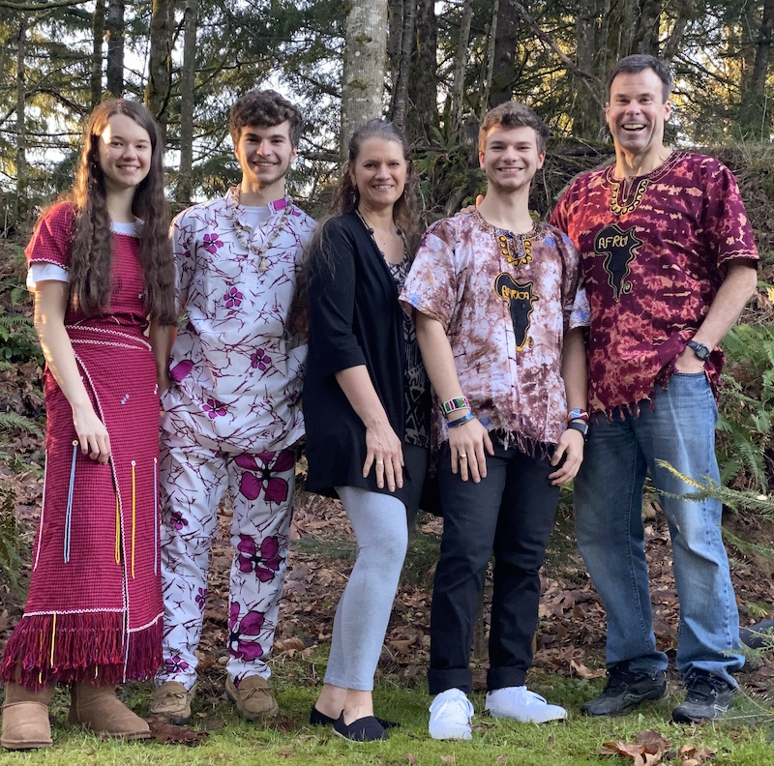
- Alyssa will be completing her high school education and simultaneously graduate with her AA degree in June. Please pray as she chooses her next steps as she has much potential but is most interested in studying the Bible and serving the Lord.
- Keep Adam (22) in your prayers as he continues his Masters of Divinity degree at one of the top evangelical seminaries in the country (Southern) and seeks God’s leading where he will serve in the future. Keep Andrew (almost 21) in your prayers as he pursues his next steps in real estate, having completed his real estate license exam.
- I’m thankful Holly was able to travel with me domestically this year, and please pray she continues to gain strength and one day will be able to travel with me globally.

In ministry
- Praise God my doctorate and dissertation are complete, and pray He uses them for His glory and the improvement of trainings globally.
- Obviously, please pray for the eradication of Covid, and that travel challenges will be eased so training of pastors can continue unhindered. For example, every trip I make to Africa requires at least 2-3 covid tests which are costly and have to fit within a certain nerve-wracking timeline. A positive result creates a domino effect of additional challenges.
- Pray for God’s grace upon existing ministry partners (global and domestic) and His leading in connecting with new potential partners. Pray that God will grant me wisdom in launching new networks and maintaining existing networks toward expanding Pathways throughout Africa and globally.
- Praise God with us for the wonderful work He has been doing as we anticipate and rely on His continued activity.

Submitted with appreciation for our supporters and gratitude to our awesome God.
Eric Belz, Africa Director for Pathways Bible Training
Cell: 360.915.3921
Email: eric.belz@efca.org
Website: www.belzglobal.com

