2019 Annual Report for Eric Belz
Africa Director of Pathways Pastor Training - EFCA/ReachGlobal

- Your Ministry: Explain your ministry in one-two sentences for a lay person.
My ministry is to train African (and global) pastors and church leaders to study, obey and teach God’s Word well, equipping them to pass this training on to others. At the same time, I equip US pastors to assist in this work and conduct doctoral research analyzing factors contributing to how global pastors utilize Pathways Bible Training.

- Strategic Value: Tell why your ministry is important or strategic and how it fits into the “big picture.”
This ministry is important and strategic because most pastors in the majority world do not know how to study, understand and teach God’s Word to their people or how to use it to grow healthy, Christ-honoring churches. Over 90% of pastors in the Global South have received no formal training, so they slide into on false teaching such as prosperity theology, syncretism and working to earn salvation, all of which hurt the cause of Christ. The training we offer grounds them not only in the truths of Scripture, God’s revelation of Himself and His will for us in Christ, but it also gives them tools so that pastors can study and teach God’s Word well and grow their churches on a biblical foundation. This will lead to healthy ministries based on the Word, God’s kingdom will grow authentically, and disciples will be made of all nations (Matt.28:18-20), all of which honor and glorify Christ, which is the “big picture.” The series of nine Pathways workshops we offer over three years is effective for long-term change on a trajectory for exponential growth. The trainings are reproducible and sustainable because they are “owned” and driven by nationals. The multiplication of the trainings to other pastors is embedded in the DNA of the training, so hundreds and thousands of pastors can receive much needed training.

- Scriptural Basis: Give one or two Scripture verses and explain how they undergird your ministry.
Obviously, there are MANY passages I could reference, but a couple which are fundamental for our ministry are Ezra’s commitment as he “set his heart to study the law of the Lord and to practice it, and to teach His statutes and ordinances in Israel.” (Ezra 7:10) We long for pastors and church leaders to grow strong spiritually by studying God’s Word and obeying it (2 Tim.2:15). The Bible is our foundation and what we base our lives and faith on, “so the man of God may be adequate, equipped for every good work.” (2 Tim.3:17) Beyond this, we are raising up movements of leaders who can preach/teach the Word well (2 Tim.4:1-5), giving the understanding of its meaning to God’s people (Neh. 8:8), for God’s Word is our authority and the substance of our message. Finally, we strive to equip leaders who will pass this training on to others, as Paul tells Timothy in 2 Tim.2:2. We desire that solid, exegetical study and expository preaching of the Word would be spread and multiplied to every tongue and tribe and nation, to the glory of Christ through the work of His Spirit.
- Motivation: Why do you continue to do what you do?
I cannot imagine a more fulfilling calling than to bring glory to God by equipping leaders to study, obey and teach the Word well. Lives are transformed and movements are launched that impact communities, regions and nations for the Gospel. The needs are so profound globally and national leaders are so hungry for our training. God has shaped me through my energy level, ministry experience, past training and skill sets in such a way to connect well cross-culturally with pastors and leaders, to develop them so they embrace the truths of Scripture, to empower them to obey His Word, and to release them so they preach His Word with truth and power, and train others to do the same. Pastors and leaders are learning the Gospel, in some cases for the first time, congregations are being transformed, authentic Bible-preaching movements are spreading, and God is being exalted. What could be more rewarding? As you read our newsletters, you hear the flow of testimonies from global pastors who testify how they and their ministries have been changed, and this continues to inspire me.
I was just with Pastor Rafael from Guatemala a couple weeks ago who said, “Pathways has brought a total change in how I preach and how I see people and how I apply the Word of God.” Ministry leader and co-pastor Dina shared that she has become more discerning of dangerous interpretive patterns, like expecting God to give us what we want, that flow from a lack of knowledge and submission to the Word. Just last Friday evening I received this text from rural southern Kenya, from my good friend Rev. Kioko Mwangangi, coordinator of our network in that region. This network is three months from completing a full three-year Pathways cycle. After he finished a regional council meeting with leaders of his denomination he shared: “It has been a good journey and at the meeting members talked very well about Pathways (our training). This program has contributed to the preaching of the Word of God in our region in a way that I cannot explain except to label it as God’s grace! We did not deserve such attention and commitment from your team but the Lord gave us. We will be forever grateful.” Why do I do what I do? That’s why! Praise God for His grace. Preaching in local African churches and being used by God to lead people to Christ is always a tremendous encouragement, as happens in almost every country I visit. In most places I travel, I stay with pastors in their homes. Although oftentimes they have no electricity or running water, staying together is a mutual encouragement as we celebrate joyfully our relationship and union in Christ. The work is challenging and eternally significant, and I’m grateful to be a part of what God is doing.

- Priorities: How do you decide what ministry activities to do and what not to do?
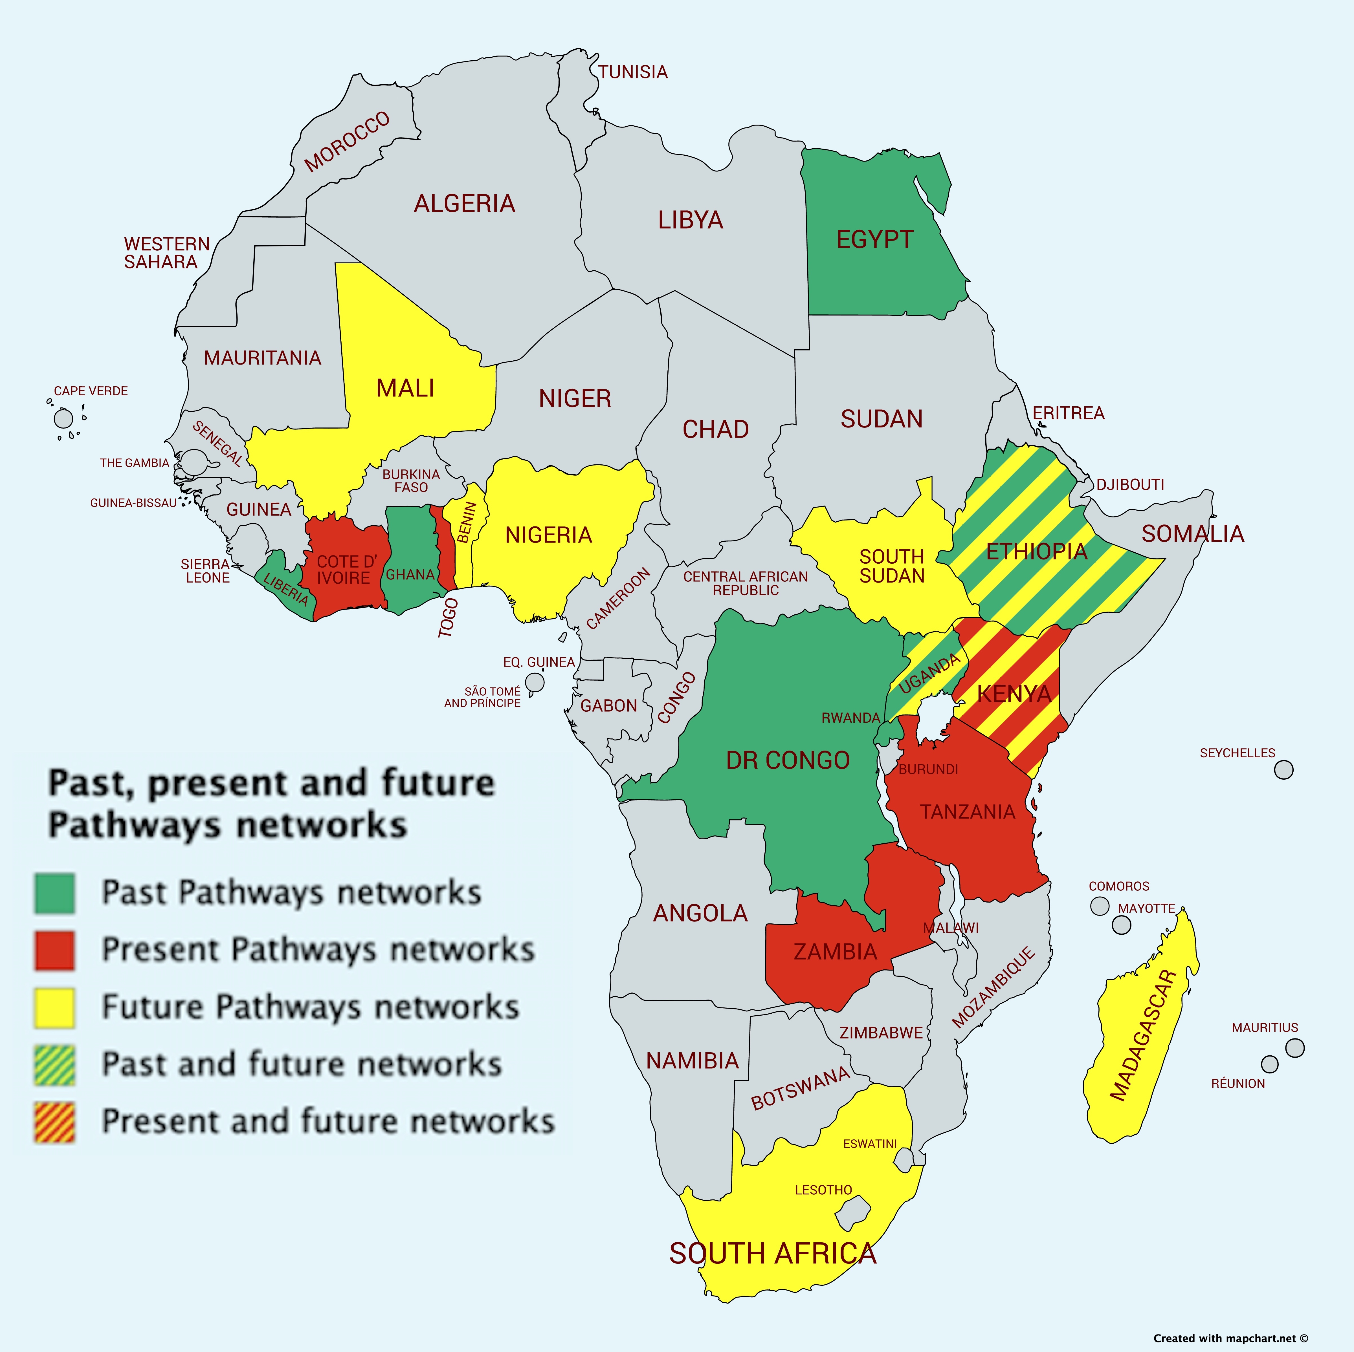
This is a real challenge. There are so many opportunities globally where pastors are waiting for us to deliver this training, and we want to be strategic and guard against spreading ourselves too thin. For example, next year, I’m planning to launch or maintain Pathways networks in Zambia, Tanzania (2 networks), Ivory Coast, Togo, Kenya (3 networks), Benin, Ethiopia, Uganda, Madagascar, and perhaps in Nigeria. This map may help to show the work we are involved in:

For this reason, in addition to training pastors overseas, we also train pastors and church leaders in the US, so they can be mobilized to train leaders globally. In this way, we can reach far more pastors than just our Pathways team members could. Also, we work as part of a team (Global Equipping in ReachGlobal / EFCA) and with ReachGlobal Africa Division to determine where the fields are the “whitest” and leaders are most ready and in need of our training. Before launching any new network, I work closely with national leaders in each country, carefully selecting the network coordinator and master trainers, and setting up a detailed plan for how multiplication of the training will happen. All is brought before the throne of God and we submit to the Spirit’s guidance. Personally, I also am accountable to my team leader and make sure that my wife supports the work I’m doing, and I’m not stretching myself too thin. I’m proceeding well through my demanding but rewarding doctoral studies which will be of great assistance to our team and many others in offering insights into hermeneutical training for pastors globally.

- Successes and Challenges (Results): What are some of the encouragements you’ve seen this past year and what are some challenges?
Successes - I have been encouraged in many areas this year.
- Indigenous church and leader transformation – Because I am doing doctoral interviews with graduates of our program all over the world, I am learning much about the enormous impact Pathways is having globally. I regularly hear reports about men who are returning to church because finally God’s Word is being preached instead of the pastor just rambling about his ideas. Church members are being more discerning of messages they hear, testing the message against God’s Word. For video testimonies, CLICK HERE.
- Growth and Reproduction - The deepest encouragement is not what we hear from people, but what we see in their lives. Pastors embrace and implement this training in their ministries, and we evidence the growth in how they preach in our workshops. They also are passionately passing the training on to others they know. The things we most value, we share with others. Nearly every pastor I regularly work with overseas (several hundred pastors in locations all over Africa and globally) is training other groups of pastors and church leaders in their regions. In this way, we estimate we may be reaching several thousand pastors just in the continent of Africa, and many more in their congregations and ministries. Although I continue to assist with funding the first-generation trainings, there is a strong sense of ownership by participants as they prepare for trainings, raise funds, and pass trainings on.
- US pastors - I’ve also been encouraged to see the receptivity of our Bible training among US pastors, many of whom are motivated to help train overseas. I have brought several pastors with me, and in some cases, they are now fully facilitating trainings. These US pastors share how Pathways training is helping them even in their own weekly preaching, sharpening their skills.
- Team - I am a part of a very healthy, mature team of like-minded missionaries/ pastors who are passionate about seeing God glorified in what we do. As our vision statement says, we do this “by equipping reproducing leaders globally for kingdom transformation and expansion.” It is a joy to serve along with them, and they completely support my leadership of Pathways Africa. Our team website is: www.pathwaytrainers.com
Challenges – Some of the difficulties we have faced are:
- Growth Pains – There are far more venues waiting to be launched than we are able to follow through to completion, and so we must guard against over-commitment. While I try to train US pastors to join us, it can be difficult to mobilize them to the point where they are joining us annually. Please pray for wisdom in how to address this issue, and perhaps that God will provide African partners to assist me and the funding to make this a reality.
- Tracking Progress – While my doctoral research is helping in this area, it is difficult to track with any precision what the pastors are doing with the trainings we give them, since we attend neither trainings they offer nor typical services in their churches where they preach.
- Multiplication and Funding – We are finding that in some of the locations where we launch networks, while the master trainers eagerly receive and use the material, the multiplication goals we set with national leadership are not fully met. This is oftentimes due to cross-cultural issues (e.g. younger pastors can’t train older ones), funding challenges, busy schedules, denominational resistance, and the like. Indigenous pastors have very little money, struggling to feed their families much less pay for first or second-generation trainings. While trying to guard against unhealthy dependency upon western funds, we try to guide them to locally-driven solutions and offer subsidies to offset training costs, transportation, translation of material, etc.
- Few stateside preaching opportunities – Because I am traveling quite a bit, and in general pastors in America tend to hold tightly onto their pulpits, I don’t get many opportunities to preach when I’m stateside. Although I’m certainly willing, I leave this to the Lord, and when opportunities come along, I joyfully embrace them. To hear a recent sermon, CLICK HERE.
- Personally, financial challenges – Because of additional personal expenses due to Holly’s and Alyssa’s health issues, we are finding we are stretched quite thin financially. We are trusting in our faithful God to provide what we need, and are praying for wisdom how to live within our means.

- Growth: How are you growing and what are you learning from God and Scripture?
As I prepare for and deliver messages from the Word, whether in Africa or stateside, growth is inevitable. As I frequently tell our pastor-trainers, we give to our people out of the overflow of what we receive from God through His Word. As I prepare for and give messages and train others to do this, I am finding my own hermeneutical and homiletical skills are improving as I apply the tools we teach to pastors. I am learning that what we are doing is not just preaching the Word, but we are training an army of faithful students and preachers of the Word, men and women who are submitted to God’s will by obeying the Word. As this work grows, I am convinced that this ministry is not about me, but it is all about God, His Word, and empowering others to handle His Word well (2 Tim.2:15). In recent studies of grace, I am challenged to fight against an entitlement mentality so common in America, and instead to be grateful and content with all God gives.

- Future: What ministry goals and plans do you have for the next year?
In our team, I am directing the trainings and networks for the continent of Africa, and so I am pouring myself into growing our training ministry in all regions of Africa. I am hoping and praying in God’s time I will find a colleague who can be my partner in directing this work in Africa – it’s a big continent after all! As I shared previously, by God’s grace, I have set an ambitious target in 2020 to launch or maintain Pathways networks in Zambia, Tanzania (2 networks), Ivory Coast, Togo, Kenya (3 networks), Benin, Ethiopia, Uganda, Madagascar, and perhaps in Nigeria (see map on page 3), as well as maintain connections and coaching with several completed networks. I will be making about 10-11 training trips internationally in 2020, and also several other stateside trainings, mission conferences and meetings in the US. I also hope to visit some of our supporting churches. Since I live in the Pacific Northwest, I have trained a group of pastors in this area as well as trying to train other pastors throughout the West. I hope to develop a team of at least 30 US-based pastor-trainers for Africa allowing me to launch new locations and support our existing networks, but I still have a long way to go. I will also continue coaching pastors in each of our international training venues, encouraging them to pass the trainings on to others. I will also be available to our other Pathways team members and Global Equipping team members for assistance in their global trainings as well as helping with various team tasks. In addition to all this, I will be continuing my doctoral dissertation work, finishing interviews and doing much analysis, research and writing, hopefully leading to completing my dissertation by the end of 2020.

- Finances: What are your financial needs to accomplish your ministry?
We are very thankful for the many partners, both individuals and churches, who give sacrificially so I can continue training pastors internationally. We cherish the relationships we share, and pray they continue long into the future. For an update on our mission work financial situation, CLICK HERE. By God’s grace and through the faithful, generous partnership of our support team, we have a bit of margin in our ministry account, although this balance is decreasing due to the following factors:
- As the ministry expands, the number of trips I make and ministry-related expenses are increasing. I work hard to book the cheapest travel and stay in low-cost accommodations, but rising expenditures are inevitable.
- As the ministry expands, the needs of the African pastors with whom we work also expand, and I must help subsidize their costs to come to the trainings, covering translation costs, food, transportation, etc. We encourage the pastors to take ownership of the trainings, and yet they have very little, so as a team we have decided some subsidizing from our personal ministry accounts is appropriate.
- Expenses are increasing in our mission agency, ReachGlobal (EFCA), such as the amount we need to raise for our health insurance increasing by 20% in 2020.
- Some of our regular donors have decreased or stopped their giving due to a variety of reasons, such as loss of income, economic hardships, increased health problems, etc.
- In addition, on the personal side, Holly’s and Alyssa’s continuing health struggles result in significant expenses which exceed our income as they have ongoing treatments and must eat very specialized foods (the only ones their bodies can process). We appreciate your prayer for these issues.
At present, we are consuming our reserves at a rate of about $500-800/month to meet our increased ministry expenses. As all of you who know me are well aware, I am a very frugal person, so rest assured that I’m seeking every means to cut costs. In addition, personally we are striving to cut any unnecessary expenses to live within our means, but with two boys in college and health issues of the girls, it is challenging. We appreciate your prayers that God will provide the funds necessary to meet these needs. At the same time, we are trusting Him and confidently moving forward in ministry.

- Prayer Requests: What are your biggest ongoing prayer requests?
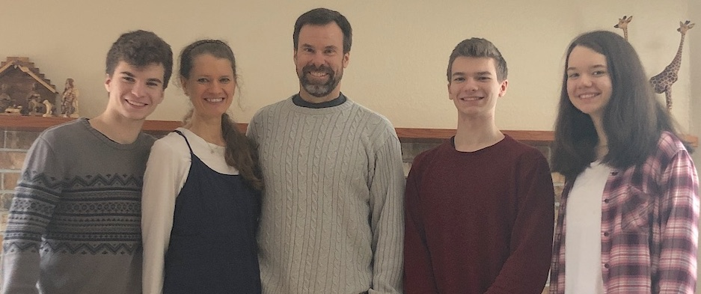
Personally, we would continue to ask for prayer for complete healing for Holly and Alyssa (15 yrs old), both of whom are still struggling with health issues that leave them very low in energy, feeling sick and miserable, with toxicity, parasites and dysfunction in their organs, inability to process most foods, etc. Alyssa is in an online academy which provides flexibility in her daily schedule. Holly seems to be making slow improvement and so we continue to pray. Since I travel quite a bit, please pray that the family will not just survive but will thrive while I’m away and that we will stay connected as a family even though we are physically apart. We would ask for prayer especially starting in January when both the boys will be living away at university and so Holly and Alyssa will be home alone when I’m gone on trips. Praise God all the kids are walking with Christ.

In ministry, please pray for wisdom in launching new training networks, and God’s Spirit and energy in maintaining existing ones. Pray for US partners to help us facilitate trainings, and that our African trainers will be faithful to pass the trainings they receive on to other pastors and leaders. Praise God with us for the wonderful work He has been doing, and we eagerly anticipate and depend upon His continued activity.

Submitted with appreciation for our supporters and gratitude to our awesome God.
Eric Belz, Africa Director for Pathways Bible Training
Cell: 360.915.3921
Email: eric.belz@efca.org
Website: www.belzglobal.com

